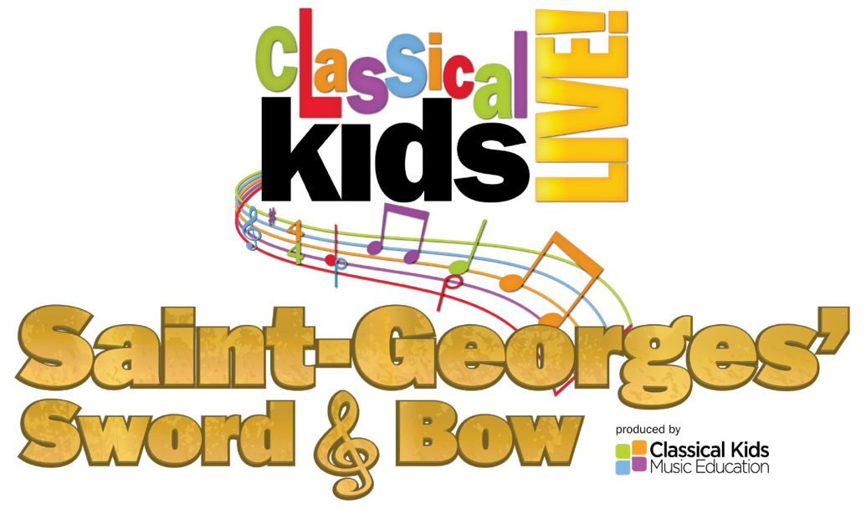

Featuring
SOMEONE as Giselle
SOMEONE as Joseph Bologne

Co-Directors
RON OJ PARSON & PAUL PEMENT

Playwright
GILL SOTU

Creator & Producer
PAUL PEMENT

Music Editor/Arranger
JIM STEPHENSON

Series Creator
SUSAN HAMMOND

Music Consultants
DANIEL BARTHOLOMEW-POYSER, RACHEL BARTON PINE, MINA ZIKRI, DR. MEGAN HILL & DR. ALLAN BADLEY

Classical Kids Music Education is funded in part by

Classical Kids® is a trademark of Classical Productions for Children Ltd.,
used under exclusive license to and produced by Classical Kids Music Education, NFP.
Classical Kids CDs/Merchandise Available at www.ClassicalKidsLive.com
Follow us! Facebook @ ClassicalKidsLive / Instagram @classicalkidslive

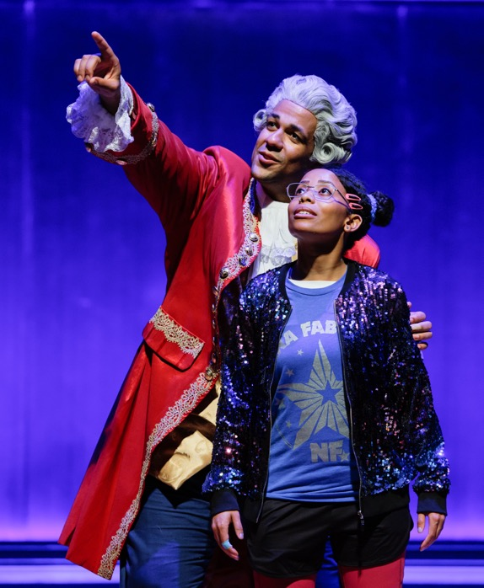
Actor Credit: Jonah D. Winston & Brandi Jiminez Lee

MUSICAL EXCERPTS

- Overture — L’ament anonyme, Overture
- Concerto in A Major, Op. 5, No. 2:1. Allegro moderato
- Concerto pour violin no 9 en sol (in G) majeur op 8: Rondeau
4A. Symphony No 1 en sol majeur, Op 11 Allegro assai
4B. Symphony No 1 en sol majeur, Op 11 Allegro assai (Continued)
- Symphonie No. 2 en ré majeur, Op. 11: Presto
- Reprise of Cue 5 - Symphonie No. 2
- 2 Violin Concertos Op 2, No 2 in D Major
- Orefeo ed Euridice – Dance of the Blessed Spirits by Gluck
- Scale by Concertmaster
- Gossec Trio in F Major Op 9, No 3:1. Allegretto
- Gossec Sinfonia In G Major: 1. Allegro Molto
- Violin Concerto in C Major, Op. 5, No. 1: II. Andante moderato
- Concerto pour violon No. 9 en sol majeur, Op. 8: Largo
- Scena from “Ernestine"
- Symphonie No. 2 Remix (Hip-Hop Dance)
- Concerto for Violin and Orchestra in A. Op. 7 No. 1 – Allegro moderato
- Haydn Symphony No. 85 in B-Flat Major, Hob. I:85 “La reine”: IV. Finale. Presto
- Haydn Paris Symphony No. 82 in C Major, Hob. I:82 “L’ours”: I. Vivace assai
- Giselle’s Rap (Boots n Cats)
- Reprise of Cue 18 - Haydn “L’ours”
- Symphonie Concertante in A Major, Op 9, No. 2:I. Allegro
- Mozart - Flute Quartet No. 1 in D, K. 285
- Violin Concerto in D Major, Op. posth., No. 2: Adagio
- Feeling Good – Nina Simone
- Violin Concerto in D Major, Op. 3 No. 1: II. Adagio
- Concerto pour violon No. 9 en sol majeur, Op. 8: Allegro
- Reprise: Symphonie No. 2 en ré majeur, Op. 11: Presto

PLOT SYNOPSIS
Hoping to become the next great pop sensation, a young girl discovers her music teacher was the biggest star in 18th century France. In this time-bending musical adventure, Giselle learns about life’s triumphs and tragedies from the most accomplished man in Europe, the Chevalier Saint-Georges. A captivating story of of passion, dreams, legacy, and hope. #Saint-Georges!
The story of Saint-Georges’ Sword & Bow is centered on a rivalry as old as time: classical vs. contemporary. Thirteen-year-old Giselle is dead set on becoming a famous pop star; her father insists that studying music theory is much more important. The supernatural arrival of Jospeh Bologne, Le Chevalier de Saint-Georges, whisks Giselle back in time to learn about Bologne’s personal life and professional passions. As she gets to know Joseph, his complicated story, and his incredible compositions, Giselle realizes that there might be more to classical music than meets the modern ear.

PRODUCTION NOTES

Saint-Georges’ Sword & Bow is a theatrically staged concert presentation designed to introduce family and student audiences (children 6-12 and their parents) to the life and music of Joseph Bologne, Le Chevalier de Saint-Georges. This educationally entertaining production presents 25 beloved works by Saint-Georges and his contemporaries.

Classical Kids Music Education is a Chicago-based nonprofit with a mission to provide children with an exciting and educational point of entry into the world of classical music by humanizing the lives of the great composers, creating an emotional connection to their musical masterpieces, and inspiring a personal excellence that leads to greater achievement and success in life. Its Classical Kids Live! symphony concert series serves as one of the worlds best educational outreach and community engagement programs contributing to the long-term health of classical music. Having received more awards and honors than any other entity of its kind, Classical Kids is proud to say, “We’re making a difference!”

Far And Away the Best for Introducing Children to Classical Music!”
– Boston Herald

"One of the Most Completely Wondrous Examples of Children's Entertainment Ever!"
- Billboard

"Art Made Accessible: Nobody Does it Better than Classical Kids!"
- Entertainment Weekly

"The Best Way to Unlock the Mind and Heart of a Child to the Wonders of Musical Masterpieces!"
- New York Daily News

Classical Kids CDs, Digital Recordings & Teaching Editions available at www.classicalkidsnfp.org
The theatrical concert version of Beethoven Lives Upstairs is an adaptation of the best-selling and award-winning Classical Kids
audio recording, Beethoven Lives Upstairs, produced by Susan Hammond and originally directed as a staged concert by Peter Moss
with additional direction by Dennis Garnhum. Classical Kids® is a trademark of Classical Productions for Children Ltd.,
used under exclusive license to and produced by Classical Kids Music Education, NFP.

ARTIST BIOGRAPHIES

Brandi Jiminez Lee – Giselle
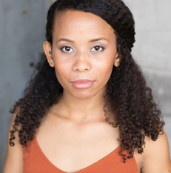
Brandi was born and bred in Chicago. As a kid, she discovered her love of music in her father's music studio, creating and playing songs on his guitar. Periodically, she pretends to be a music star while playing Rock Band with family. She's a thriving educator, actor, writer, and director. She graduated from Columbia College Chicago and earned an MFA in TV and Screenwriting from Stephens College. Recent credits include The Strange Case of Dr. Jekyll and Mr. Hyde (Idle Muse Theater Company), Try to Be (La Vuelta), Crumbs from the Table of Joy (Raven Theatre), Akeelah and The Bee (Adventure Stage), Thumbelina and Anna Karenina (Lifeline Theatre).

Demetra Dee – Giselle
Demetra Dee is elated to be making her Classical Kids debut as Giselle in Saint Georges’ Sword and Bow. As a kid, Demetra was always singing, dancing and putting on a show for her family. When she was 12 years old Demetra saw her first musical, Ragtime. She sat in awe of this incredible story being told right there in front of her, and it was in that moment that she discovered her love for storytelling, her God-given purpose. She hopes that each of you are inspired by Saint Georges’ story to never give up, to work hard to be the best you can be, and to live on purpose, in your purpose. Some of her other credits include: Chlorine Sky (Steppenwolf); Cullud Wattah (Victory Gardens Theatre); Relentless (Goodman/Timeline Theatre); The Last Pair of Earlies (Raven Theatre); Middle Passage (Lifeline Theatre); Be Here Now (Shattered Globe); Crumbs from the Table of Joy (Raven Theatre US/performed) Comfort Stew (ETA Creative Arts); The Colored Museum (Pegasus); Migration (ETA Creative Arts). She is represented by DDO Chicago. www.demetradee.com (Mark 10:45)

Kelvin Roston Jr. – Joseph Bologne
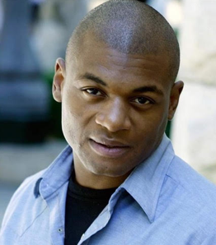
Kelvin is excited to be a part of the Classical Kids team with this production of Saint-George’s Sword and Bow! He has been performing since a child, playing a priest at the age of 4. Kelvin was raised in his grandfather’s church in St Louis MO and served as the musician. He was introduced to the St Louis Symphony Orchestra while in high school. Some of his performing credits include: The Gospel at Colonus (Oedipus), Oedipus Rex (Oedipus), King Hedley II (King Hedley), Five Guys Named Moe (Four-Eyed Moe), Clue (Mr. Green, Mercury Theater); The Color Purple (Mister, MSMT); The Wiz (The Wiz, Fulton Theatre). Other theaters include: Congo Square, Paramount, Marriott, Goodman, ITC, eta, Writers, Black Ensemble, TimeLine, Northlight, Steppenwolf. International: Orb (Tokyo, Japan); Festival Hall (Osaka, Japan). Television: Chicago Med, Chicago P.D., South Side. Film: Get a Job, Princess Cyd, Breathing Room. Awards: Jeff Award, three BTAA Awards, two Black Excellence Awards, NAMI Award. AEA, Paonessa Talent.

Jonah D. Winston – Joseph Bologne
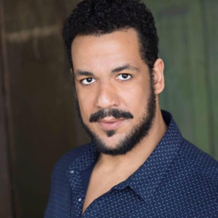
Jonah is overjoyed to be a part of Classical Kids Live! and helping to bring to life the story of Joseph Bologne, le Chevalier de Saint-Georges! A graduate of Butler University in Indianapolis and Flinders University in Adelaide, South Australia, some of Jonah's favorite roles include Colonel Mustard in Clue (Mercury Theatre Chicago), Little John in Ken Ludwig's Sherwood (Cleveland Playhouse), and Robert in the national tour of The Play That Goes Wrong. He has also performed at the Lyric Opera of Chicago, Illinois Shakespeare Festival, The Goodman, Indiana Repertory Theater, and Writers Theater, among others. Film/TV credits include Chicago Fire, Chicago P.D., Lacy's Christmas Do-Over, Evil Lurks, and The Resentful Angel. Jonah was first introduced to theatre at the age of 5 years old when he played Papa Bear in a youth production of Goldilocks and the Three Bears, and he remembers going to Classical Kids Live! performances himself; seeing Beethoven Lives upstairs when he was just 7 years old!

Ron OJ Parson - Director
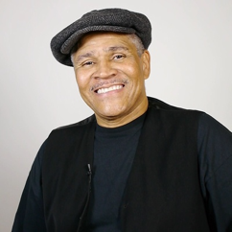
Celebrated director Ron OJ Parson hails from Buffalo, New York and is a graduate of the University of Michigan’s professional theatre program. Ron is considered director royalty in Chicago, is a Resident Artist at Court Theatre, and has worked at such established institutions as Steppenwolf, Goodman, Victory Gardens, Congo Square, Black Ensemble Theater, ETA, Chicago Theatre Company, Northlight, Writers’ Theatre, Eclipse Theatre, and UrbanTheater Company.

Paul Pement - Creator, Producer, Co-Director
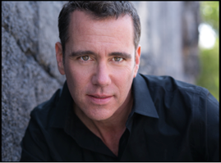
Paul serves as Executive & Artistic Director of Classical Kids Music Education, a non-profit arts organization focused on introducing children (and their parents) to the lives and musical masterpieces of the great classical composers. A BFA in theatre from the University of Illinois Urbana-Champaign and professional experience as an actor, singer, dancer, director, choreographer, and stage manager have enabled Paul to achieve success with Classical Kids LIVE! programming - the “gold-star” leader in the field for creating theatrical family concerts presented by professional symphony orchestras throughout North America and abroad. Production titles include Beethoven Lives Upstairs, Mozart’s Magnificent Voyage, Vivaldi’s Ring of Mystery, Tchaikovsky Discovers America, Gershwin’s Magic Key, and the newest in the series, Saint-Georges’ Sword & Bow.

Gill Sotu – Playwright
Mr. Sotu is a two-time Grand Slam Poetry Champion, two-time Raw Performing artist of the year, multiple TEDx presenter, and commissioned playwright with The Old Globe Theatre as well as other prominent theatres throughout southern California in partnership with La Jolla Playhouse. He is also a teaching artist with the Globe and Playhouse while serving as the official Poet in Residence for the San Diego Writer’s Festival. Gill has been commissioned to produce original pieces for leading arts and community organizations around the country, including creating young audience symphony productions for the San Diego Symphony.

Jim Stephenson - Music Editor & Arranger
James M. Stephenson earned a degree from the New England Conservatory in trumpet performance going on to perform for 17 seasons in the Naples Philharmonic in Florida. Now a full-time composer, his catalog boasts concertos and sonatas for nearly every instrument, earning him the moniker “The Concerto King” from Chicago Symphony clarinetist John Yeh. The vast majority of those compositions came through commissions by and for major symphony principal players in Chicago, Boston, New York, Philadelphia, Minnesota, Washington DC, St. Louis, Oregon, Milwaukee, and Dallas, among others. With such prolific output, Stephenson’s music is well represented in recordings. Nearly all of his solo brass works (over 50) have been professionally recorded, and in total, his extensive catalog for all instruments can be heard on over 30 CDs.

